LAB#12 MACROS
Task#01:
Write a program that takes single character input from the user and display in new line
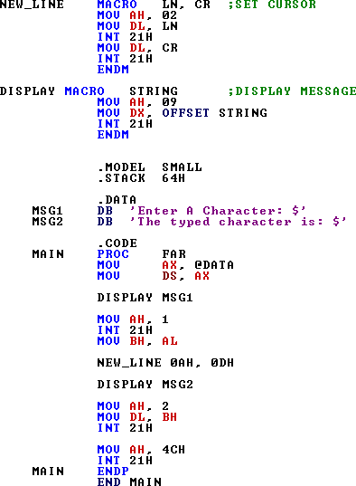

OUTPUT:
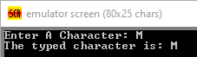

TASK#02:
Write a program to display your bio data using carriage return and linefeed macro

This study soMurcoehwiabs UdodwdnlionadCedS2by01F0-0100070857207352 from CourseHero.com on 01-06-2024 10:06:32 GMT -06:00

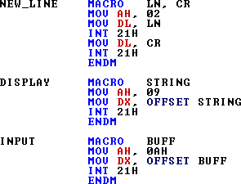

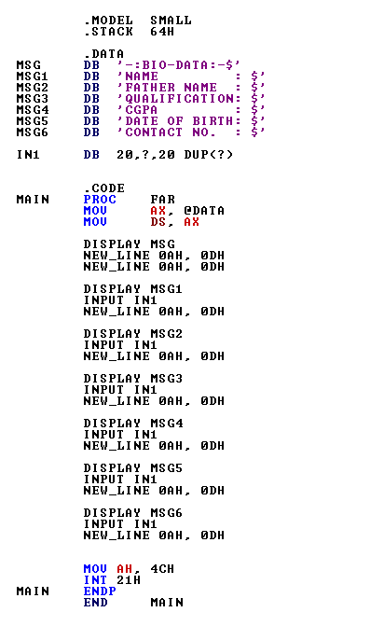
This study soMurcoehwiabs UdodwdnlionadCedS2by01F0-0100070857207352 from CourseHero.com on 01-06-2024 10:06:32 GMT -06:00

OUTPUT:
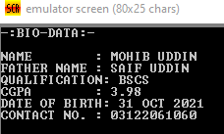
TASK#03:
Write a macro that multiplies two words by repeated addition, and then saves the result. Write a program that multiplies the following numbers using macro:
- 2000 x 500
- 2500 x 500
- 300 x 400

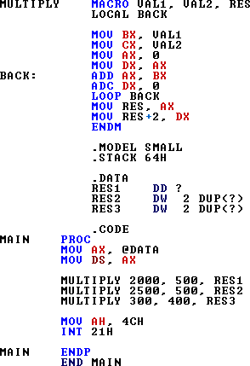

This study soMurcoehwiabs UdodwdnlionadCedS2by01F0-0100070857207352 from CourseHero.com on 01-06-2024 10:06:32 GMT -06:00

TASK#04:
Write a macro to calculate total wages which is equal to the sum of overtime, salary and bonuses. Write a program by using following values:
- Salary = 60000, Overtime = 2500 and Bonuses = 3000
- Salary = 45000, Overtime = 1000 and Bonuses = 500
- Salary = 10000, Overtime = 500 and Bonuses = 100

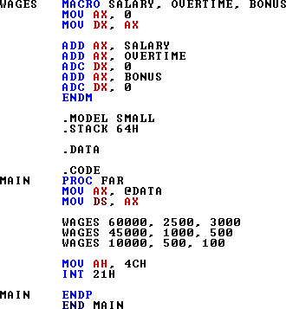

This study soMurcoehwiabs UdodwdnlionadCedS2by01F0-0100070857207352 from CourseHero.com on 01-06-2024 10:06:32 GMT -06:00

